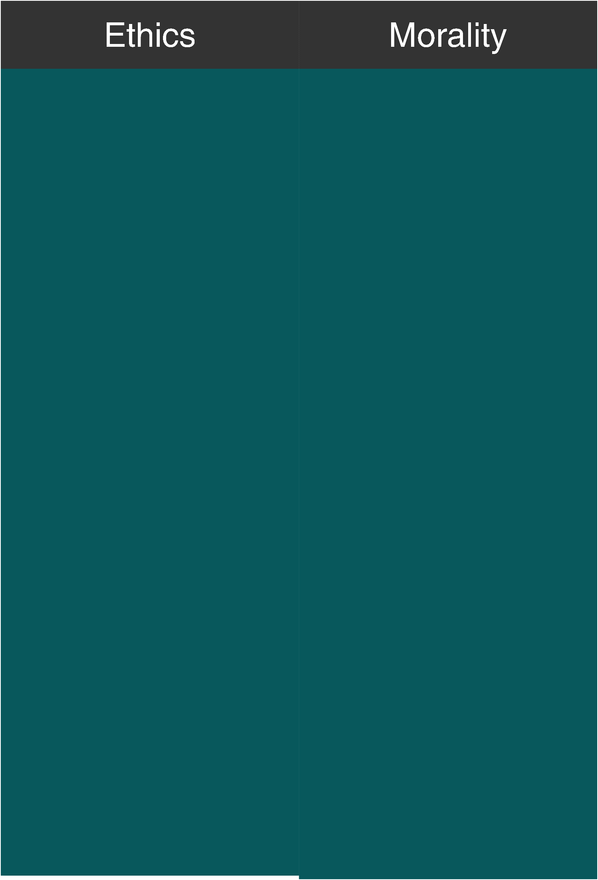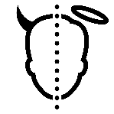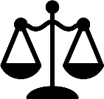

|  |  |
| --- | --- |
| External Rules. | Personal Principles. |
| The word Ethics originated from the Greek word ethos. The meaning of ethos is a character. | **The word Morals originated from the Latin word Mos. The meaning of Mos is custom.** |
| May vary between environments. | **Rarely change.** |
| System of moral values  for a particular lar society or an institution. | **Distinguishing character,**  **sentiment, moral nature, or guiding beliefs of a person, group, or institution.** |
| Moral principles that can be used as guidelines for a person, society or an institution. | **Describes the character of the attitudes and beliefs of a certain person, society**  **or an institution.** |
| Have a universal outlook. | **Comparatively more customized since it shows the identity and believes that can be distinguished**  **from others.** |
| Can be influenced by the profession, field of study, organization in which  someone works, etc. | **can be influence by the societal behavior, culture, and religion.** |
| It is uniform in  comparison with morals. | **It varies with different**  **type of culture and norms.** |
| It is somewhere related to  the professional work. | **It is not related with the**  **professional work.** |
| Ethics are dependent on the prism of others. | **Morality is seen from the perspective of an individual.** |
| Ethics are followed because society has decided that it is the right course of action | **Morality is followed because a person believes that it is the right course of action.** |
| A person who follows the ethical principles need not necessarily have strong moral values, in fact, there are even possibilities that he may not have any morals. | **There could be situations where ethics are violated by a moral person to maintain to uphold his moral values.** |